Adinkra Symbols


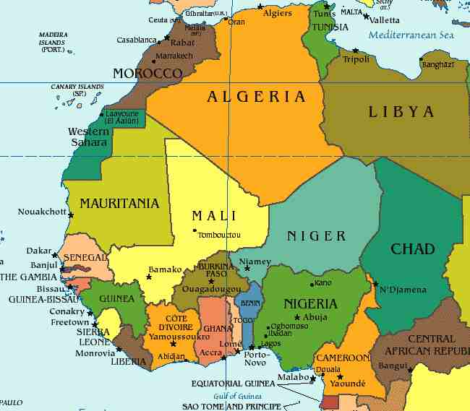

Map of Western Africa

Adinkra is a cotton cloth produced in Ghana and Côte d'Ivoire which has traditional Akan symbols stamped upon it. The adinkra symbols represent popular proverbs and maxims, record historical events, express particular attitudes or behaviour related to depicted figures, or concepts uniquely related to abstract shapes.


The Akan people (of what is now Ghana and Côte d'Ivoire) had developed significant skills in weaving by the sixteenth century, with Nsoko (present day Begho) an important weaving centre. Adinkra, originally produced by the Gyaaman clans of the Brong region, was the exclusive right of royalty and spiritual leaders, and only used for important ceremonies such as funerals – adinkra means 'goodbye'.
Over time the Asante further developed adinkra symbology, incorporating their own philosophies, folk-tales and culture. Adinkra symbols were also used on pottery, metal work (especially abosodee), and are now incorporated into modern commercial designs (where their related meanings give added significance to the product), architecture and sculpture.

Text source: http://africanhistory.about.com/library/weekly/aaAdinkra.htm

